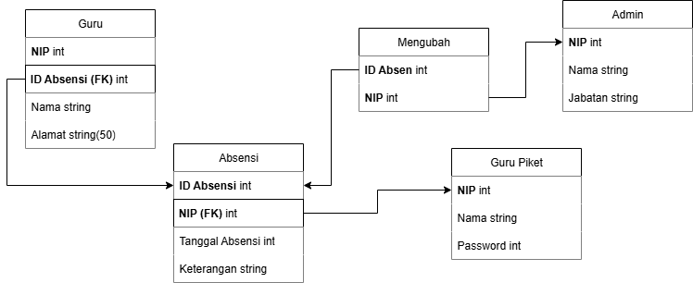

Guru

|  |  |  |
| --- | --- | --- |
| NIP | ID Absensi | Alamat |
| 198507162010021001 | Absensi_01 | Jl. Melati No. 12 |
| 197911302005012017 | Absensi_02 | Jl. Mawar Indah No. 45 |
| 199001252013051005 | Absensi_03 | Jl. Kenanga Barat No. 88 |
| 198212102008082009 | Absensi_04 | Jl. Anggrek Lestari No. 3 |
| 197605221999011014 | Absensi_05 | Jl. Flamboyan Raya No. 67 |
| 199503182020012021 | Absensi_06 | Jl. Manchester Raya No.01 |
| 198809092015071003 | Absensi_07 | Jl. Boboiboy Juang No.34 |
| 199112282019022012 | Absensi_08 | Jl. Bali Raya No.11 |
| 198303142007061018 | Absensi_09 | Jl. Kasep Asep No.21 |
| 197408011995122007 | Absensi_10 | Jl. Raya raya No.56 |

Admin

|  |  |  |
| --- | --- | --- |
| NIP | Nama | Jabatan |
| 19830615 200901 2 015 | Kapitan Suharto | Kepala Sekolah |
| 19901222 201511 1 007 | Faiz No All Bark | Wakil Hubin |
| 19751103 199804 2 003 | Kaleng Bin Kasep | Waka Kurikulum |
| 19890729 201106 1 021 | Hassa Fainudin | Waka Sarana |
| 19941118 202003 2 010 | Tallah Tal Talayah | Waka Kesiswaan |
| 19800827 200010 1 014 | Renova Lenovo | Staff TU |
| 19970630 201807 2 005 | Triokas Lokas | Staff TU |

Absensi

|  |  |  |
| --- | --- | --- |
| ID Absensi | Tanggal Absensi | Keterangan |
| Absensi_01 | 1-08-25 | Hadir: 11 |
| Absensi_01 | 1-08-25 | Sakit: 2 |
| Absensi_01 | 1-08-25 | Izin: 3 |
| Absensi_02 | 2-08-25 | Hadir: 1 |
| Absensi_02 | 2-08-25 | Sakit: 2 |
| Absensi_02 | 2-08-25 | Izin: 0 |
| Absensi_03 | 3-08-25 | Hadir: 23 |
| Absensi_03 | 3-08-25 | Sakit: 2 |
| Absensi_03 | 3-08-25 | Izin: 4 |
| Absensi_04 | 4-08-25 | Hadir: 19 |
| Absensi_04 | 4-08-25 | Sakit: 4 |
| Absensi_04 | 4-08-25 | Izin: 2 |
| Absensi_05 | 5-08-25 | Hadir: 316 |
| Absensi_05 | 5-08-25 | Sakit: 5 |
| Absensi_05 | 5-08-25 | Izin: 7 |
| Absensi_06 | 6-08-25 | Hadir: 12 |
| Absensi_06 | 6-08-25 | Sakit: 0 |
| Absensi_06 | 6-08-25 | Izin: 5 |
| Absensi_07 | 7-08-25 | Hadir: 31 |
| Absensi_07 | 7-08-25 | Sakit: 4 |
| Absensi_07 | 7-08-25 | Izin: 3 |
| Absensi_08 | 8-08-25 | Hadir: 4 |
| Absensi_08 | 8-08-25 | Sakit: 7 |
| Absensi_08 | 8-08-25 | Izin: 5 |
| Absensi_09 | 9-08-25 | Hadir: 6 |
| Absensi_09 | 9-08-25 | Sakit: 1 |
| Absensi_09 | 9-08-25 | Izin: 1 |
| Absensi_10 | 10-08-25 | Hadir: 8 |
| Absensi_10 | 10-08-25 | Sakit: 5 |
| Absensi_10 | 10-08-25 | Izin: 3 |

Guru Piket

|  |  |  |
| --- | --- | --- |
| NIP | Nama | Password |
| 19810521 200306 102 005 | Pratama Putra | 21312313213214 |
| 19900214 201104 201 017 | Khalid Khalea | 231234324435 |
| 19770730 199912 101 003 | Husbun Yojar | 213213213213213 |
| 19881205 201609 202 009 | Samanta Exodus | 2314434556656 |
| 19930611 202108 102 012 | Aksen Lionel | 7657657657657 |
| 19830918 200707 101 008 | Joestar Jojo | 87856754811188 |
| 19951127 202002 201 006 | Poli Ga Miu | 118926284841651 |
| 19760510 199501 102 001 | Gunung Gajah | 819481651561519 |
| 19900823 201311 202 014 | Patih Sultan Gajahar | 18198194474159 |
| 198411022008110101 | Husnul Yaqup | 14998421311323 |